EXPRESSION OF INTEREST

Title: Operate Café at Olympic Park
Issue Date: 27 May 2024
EOI Submission Details
Submissions Open: | Monday 27 May 2024
Submissions Closing Date:  Closing Time: | Friday 5 July 2024  3:00 pm
EOI Lodgement Instructions: | Via email to: council@cowra.nsw.gov.au  Mail: Private Bag 342 Cowra NSW 2794  Marked: The General Manager, Cowra Shire Council,  Private & Confidential EOI Café Olympic Park
EOI Questions: | Via email only to jwhite@cowra.nsw.gov.au
Draft Lease Ageement: | Available on Council’s Website www.cowracouncil.com.au or by email request to jwhite@cowra.nsw.gov.au
Inspection: | Inspection of the building is by appointment only and must be arranged by contacting Jenny White 0499845124

Council Contact & Enquiries
Name: | Jenny White
Email: | jwhite@cowra.nsw.gov.au
Phone: | 0499 845 124
Name: | Ian Thomas
Phone: | 0429 987 259

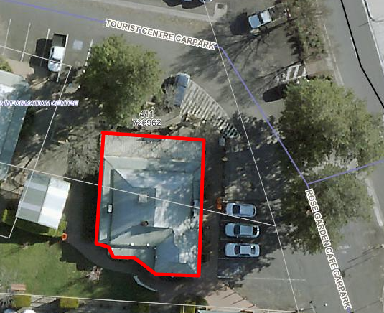

Introduction
Cowra Shire Council is seeking a skilled, motivated and experienced hospitality professional to operate the café currently known as the Rose Garden Coffee House.
Cowra is located in Central West NSW and is 190 kilometres north of Canberra and 320 kilometres west of Sydney. The Café was established in 1990 and is located within Olympic Park Crown Reserve 46688 at the corner of Grenfell, Boorowa and Young Roads Cowra. Located within Olympic Park is the Visitor Information Centre, Rose Gardens and play equipment making it an ideal spot for tourist and visitors to relax and enjoy a break.
The successful operator will collaborate with Cowra Shire Council to obtain a mutually beneficial outcome to provide a vibrant café in an ideal location.
The current lease is due to expire on the 30th June 2024. After this date Council will close the Café for a period of 2-3 weeks to complete routine maintenance and repair work. This will include but not limited to, upgrade of the existing Trade Waste System, air conditioning and painting. The new lease agreement will commence at the completion of this work.
Lease Agreement Terms:
The lease term, rent reviews, minimum base rent, security deposit and other lease terms will be negotiated and formalised with the appointed operator. The café lease agreement will be held with Cowra Shire Council as the appointed Crown Land Manager.
The proposed terms are as follows:
Annual Lease Amount: $44,000.00 plus GST plus Outgoings

Annual increase: CPI
Lease Term: 3 years with 2 x 3 year options total being 9 years

Information to be provided with the EOI

- EOIs outlining your vision for the café

- Your experience in the hospitality industry, evidence of capability/references (including personal and financial capacity)

- The lessee will be responsible to ensure all relevant health, food safety and other licences and permits are held and copies provided to Council

- Public liability insurance ($20 million minimum) must be held and copy provided to Council

- Knowledge and experience in management issues relating to running a food venue

- Proposed operating times and days

EOI Submissions and Outcomes

Cowra Shire Council reserves the right to use the Expression of Interest process in a number of different ways to advance the proposal. This includes, but is not limited to:
- information gathering to inform Council’s procurement strategy;
- developing a subsequent request for proposal;
- dealing directly with one or more respondents; and
- inviting one or more respondents to further develop their submission into a selective request for proposal.
It is important to note that, although this is an Expression of Interest process, submissions should contain sufficient detail and evidence that enables the assessment panel to make an informed decision that may lead to select a request for proposal process with one or more respondents.

Terms and Conditions
Cowra Shire Council unconditionally reserves the right to selectively negotiate with a shortlist of respondents. Cowra Shire Council is not liable for any expense or loss that may be incurred by a respondent in preparation of its response.
No contract shall exist until Cowra Shire Council and the respondent have executed a deed in writing that incorporates the outcomes of subsequent negotiations and agreed terms (if at all).
Cowra Shire Council may seek clarification from a respondent to this EOI request. Any discussions entered into with a respondent by Cowra Shire Council will be at Cowra Shire Council's sole discretion and purpose.
Cowra Shire Council unconditionally reserves the right to accept the right to accept or reject any submission regardless of compliance or non-compliance with the conditions of this EOI.

